Check for Understanding Quiz 2

Name: ____________________________ Mark: _______/20
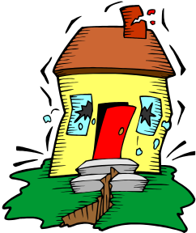

The diagram shows a house being shaken in an earthquake

- What is an earthquake?
(2 marks)

- What is the cause of an earthquake?
(2 marks)

- The map below shows the major crustal plates.

  - Use arrows and the letter E to identify on the map two places where an earthquake is most likely to occur.
(2 marks)
  - Use arrows and the letter V to identify two places where active volcanoes are most likely to exist.
(2 marks)
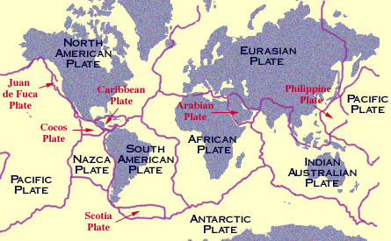

- Complete the following sentences using a word from the box below.
(8 marks)
erosion, weathering, fossils, epicentre, plates, cast, glacier, magma, seismometer, mould, tsunami, same, different, volcano, fault, fold

  - A _____________________ is the instrument used to record earthquake activity.

  - The ________________ is the point on the earth’s surface above the focus of an earthquake.

  - Earthquakes near coastal areas could cause a ____________________.

  - ________________ is the transport of rocky material from one place to another.

  - The wearing away of rock is called ______________________.

  - The earth’s crust is split into large sections called ________________.

  - When _______________________ moves up the neck of a volcano it is called lava.

  - The Darling Range was caused by a ________________ in the rocks.

- Mountains have formed by faulting and folding. Distinguish between these two processes.
(2 marks)

- Explain the difference between weathering and erosion?
(2 marks)

